# IICT – Week II – Exercises

**Question 1:** What is the exact range of 2’s complement representation using 2 bytes?

|  |
| --- |
|  |

**Question 2:** Find the decimal values of given binary numbers, then find the word being represented by the numbers using the ASCII table.

01010000 01100001 01101011 01101001 01110011 01110100 01100001 01101110

|  |
| --- |
|  |

**Question 3:** The following 24 values represent a message consisting of 24 characters stored in RAM. If the message has been written using 8-Bit Extended ASCII codes then decipher the message

87 104 97 84 32 105 83 32 89 111 117 82 32 70 105 82 83 84 32 78 65 77 69 63

|  |
| --- |
|  |

|  |
| --- |
| **ASCII REPRESENTATION** |
|  |
|  |
|  |

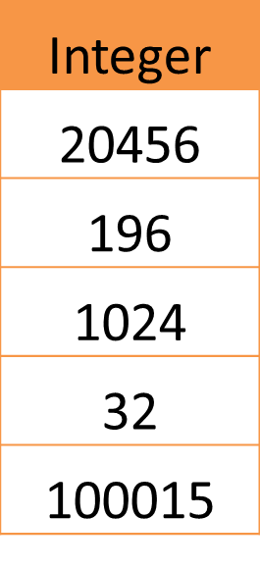**Question 4:** Represent the following integer quantities as sequence of bytes encoded using ASCII characters.

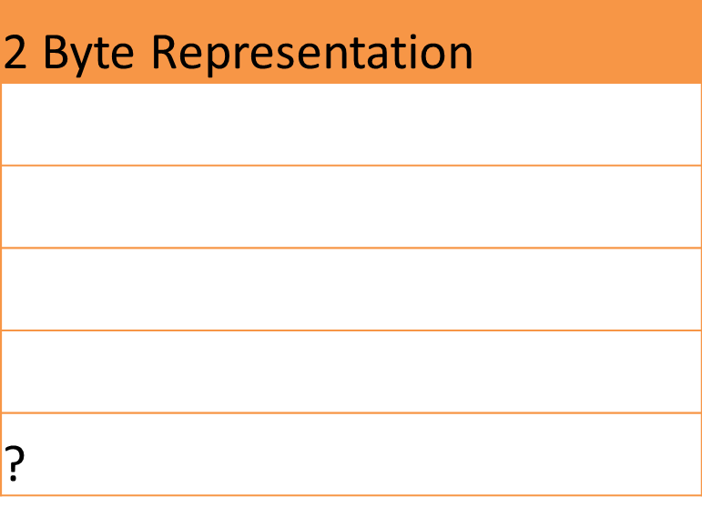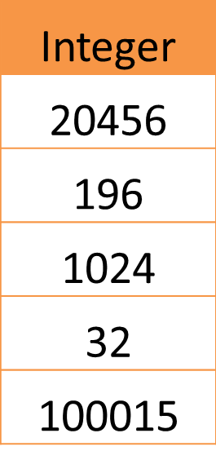**Question 5:** Use 2 Bytes to represent each of the following quantity

* What is the decimal value of 1111111111111111 if it is treated as an unsigned number? What is the value if it is treated as a signed number?

|  |
| --- |
|  |

**Question 6:** Use 4 Bytes to represent each of the following quantities.

* What is the Maximum unsigned integer value that can be represented using 4 Bytes? What is the maximum signed integer that can be represented using 4 bytes?

|  |
| --- |
|  |

**Question 7:** Represent each of the following quantity in 2’s Complement method using 2 Bytes.

|  |  |
| --- | --- |
| **Integer** | **2-Byte Representation** |
| **-53** |  |
| **-1** |  |
| **-32768** |  |
| **32767** |  |
| **30** |  |

**Question 8:** Convert the numbers into the required number systems.

|  |  |  |
| --- | --- | --- |
| **Decimal** | **Binary** | **Hexadecimal** |
| **113** |  |  |
|  | **11110100 ( two’s Complement)** |  |
|  |  | **1AF** |